Step 1: created an instance with linux OS.

2: Installed the apache server without accessing the instance using SSH i.e used the startup-script to install the apache server.

STARTUP-SCRIPT

#!/bin/bash
sudo apt-get update
sudo apt-get install -y apache2
echo "<h1>It's me ur J</h1>" > var/www/html/index.html

3: On succesful iinstallation of apache server, when accessed the web page using web browser it displayed the name that I have put into the index.html file in the startup script.

- Accessed the web page of apache server in web browser by using the public ip address of the instance.

It displayed the text that I have put into index.html file accessed the web page using web browser

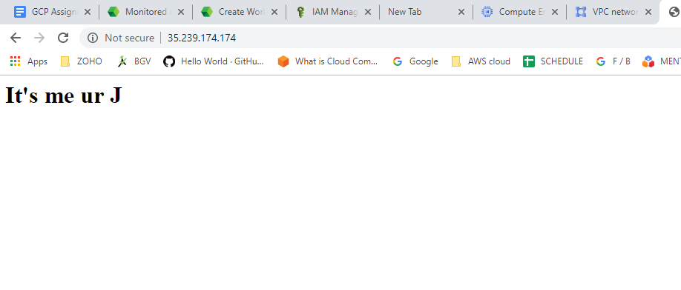

- Stopped the instance by running the below command in CLI

gcloud compute instances stop instance-10

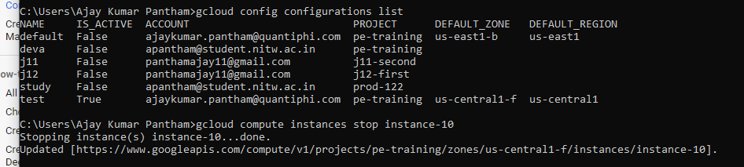

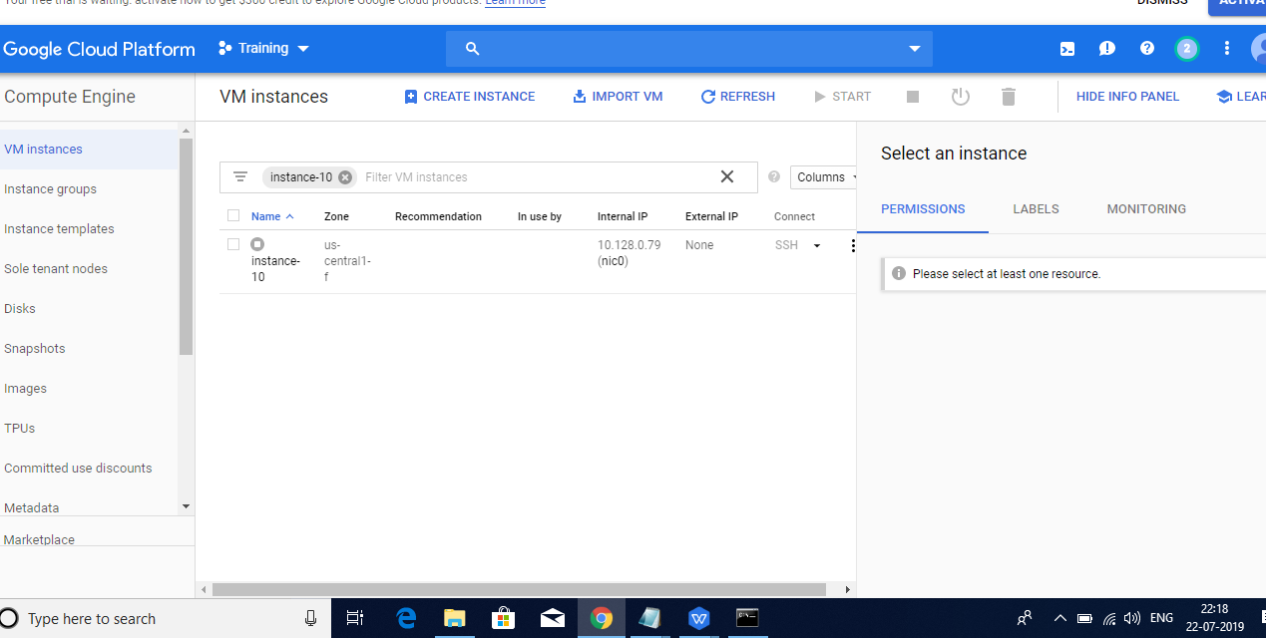

Again started the instance by running the following command in CLI

gcloud compute instances start instance-10

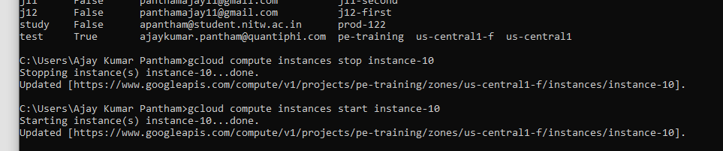

When the instanced has started again, a new public ip address will be assigned to it.

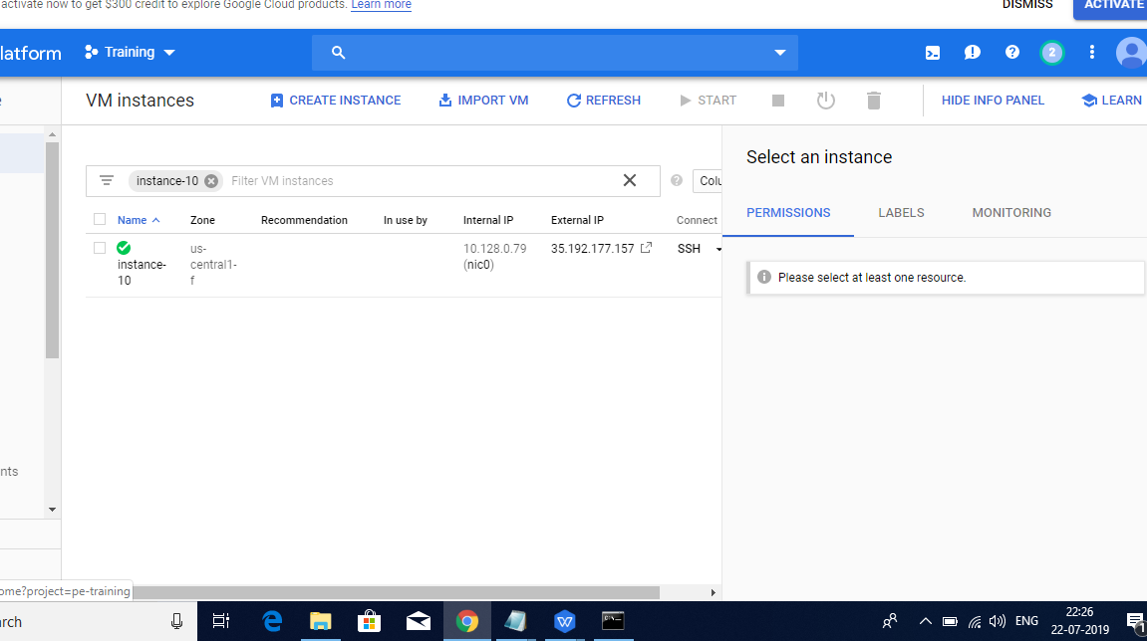

Now, when we run the webpage with the old public IP address( 35.239.174.174) of instance it does

not displayed the text present in index.html file because when the instance was stopped and again

started it’s external public ip has changed.

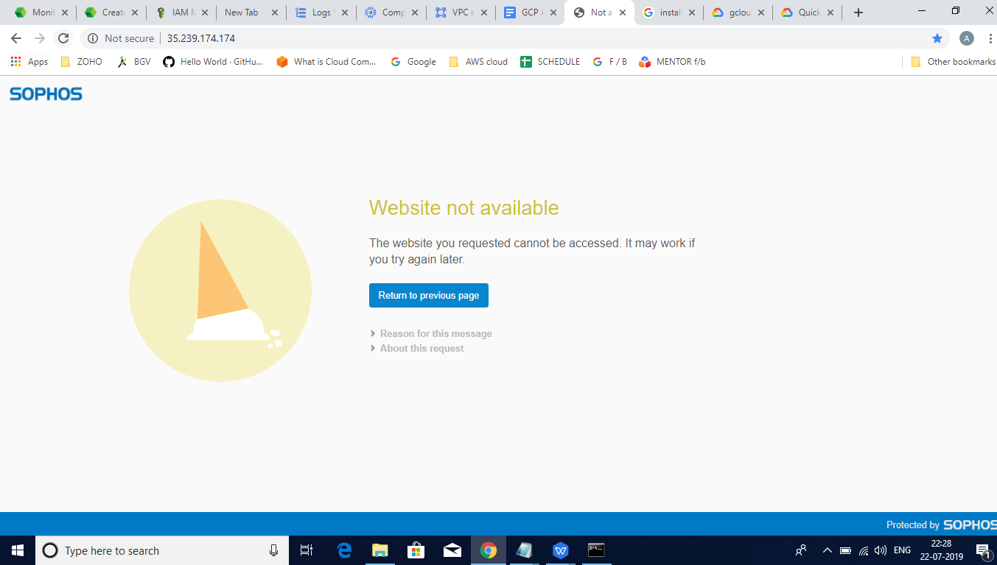

We have run the web page using the newly assigned public ip (35.192.177.157) of instance and we

could see the content present in index.html file in web browser.

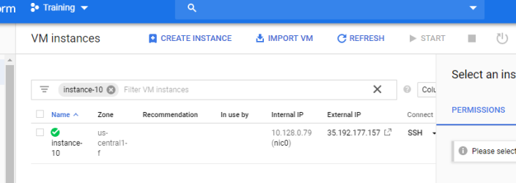

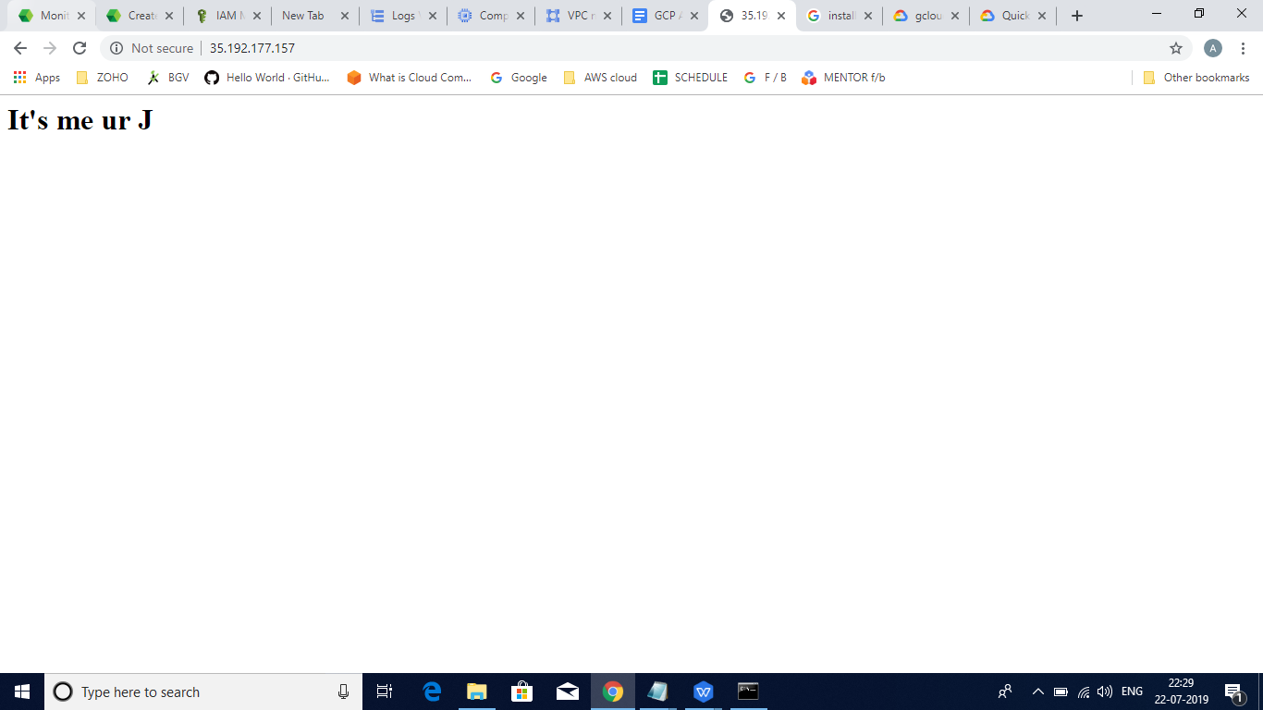

The below is the screenshot of the logs of VM instance.

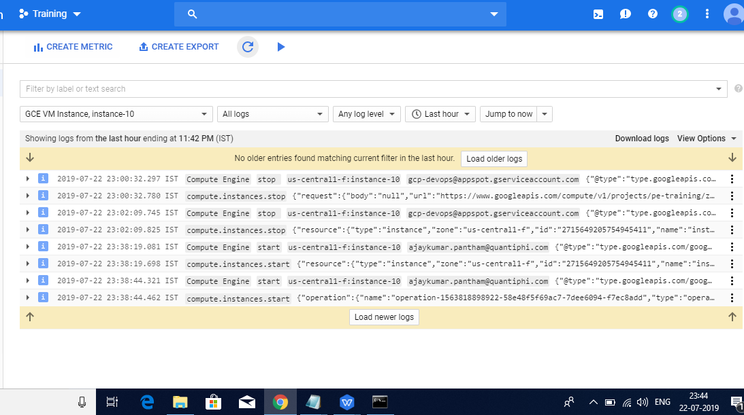

Once again started the VM instance after stopping it again. It again got assigned a new public IP

Address ( 35.193.254.240)

